**NAME**: - Jaydeep Solanki

**ROLL NO**: - 22ECG060 | 22BEC059

**COURSE CODE**: - 1CS501

**SUBJECT**: - COMPUTER PROGRAMMING

**PRACTICAL NO 2:**  C programs to illustrate working of various operators

1. Scan two numbers and display result of different arithmetic operations (+, -, *, / and %).

**Code :**

#include <stdio.h>

int main()

{

int num1, num2;

printf("Enter two numbers: ");

scanf("%d%d", &num1, &num2);

printf("Sum: %d\n", num1 + num2);

printf("Difference: %d\n", num1 - num2);

printf("Product: %d\n", num1 * num2);

printf("Quotient (integer division): %d\n", num1 / num2);

printf("Remainder: %d\n", num1 % num2);

return 0;

}

**Output:**

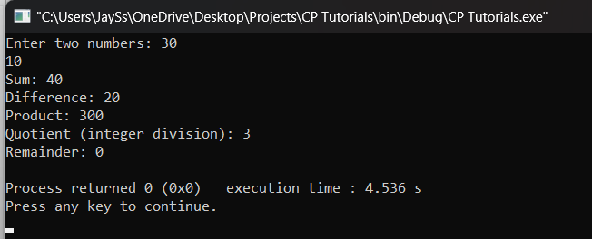

1. A company has following scheme for payment to their staff.  • Net salary = Gross salary – Deduction

• Gross salary = Basic + DA + HRA + Medical

• Deduction = Insurance + PF

• DA (Dearness allowance) = 50% of Basic

• HRA (House rent allowance) = 10% of Basic

• Medical = 4% of Basic

• PF (Provident Fund) = 5% of Gross

• Insurance = 7% of Gross

Calculate the net payment to any employee.

**Code:**

#include <stdio.h>

int main(void)

{

int basic, da, hra, medical, gross, pf, insurance, deduction, net;

printf("Enter basic salary: ");

scanf("%d", &basic);

da = basic * 0.5;

hra = basic * 0.1;

medical = basic * 0.04;

gross = basic + da + hra + medical;

pf = gross * 0.05;

insurance = gross * 0.07;

deduction = pf + insurance;

net = gross - deduction;

printf("Gross salary: %d\n", gross);

printf("Deduction: %d\n", deduction);

printf("Net salary: %d\n", net);

return 0;

}

**Output:**

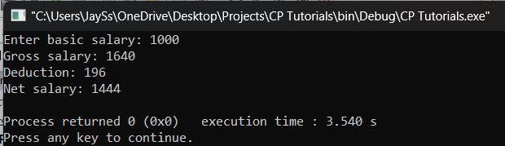

1. The driver is driving a car from city Ahmedabad to city Mumbai, in Ahmedabad temperature displays in Celsius while in Mumbai the temperature displayed in Fahrenheit, a driver wants to find the difference between the temperatures of two cities in Celsius. (Celsius = (F-32) * (5/9)).

**Code:**

#include <stdio.h>

int main()

{

float temp_ahmedabad, temp_mumbai, diff;

printf("Enter temperature in Ahmedabad (in F): ");

scanf("%f", &temp_ahmedabad);

printf("Enter temperature in Mumbai (in F): ");

scanf("%f", &temp_mumbai);

temp_ahmedabad = (temp_ahmedabad - 32) * (5.0/9.0);

temp_mumbai = (temp_mumbai - 32) * (5.0/9.0);

diff = temp_mumbai - temp_ahmedabad;

printf("Difference between the temperatures of two cities in Celsius: %.2f\n", diff);

return 0;

}

**Output:**

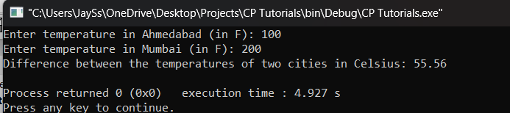

1. To calculate simple interest. (final amount A =  P_princilpal_amount(1+rate_of_interest_annual*time_in_years).

**Code:**

#include <stdio.h>

int main(void) {

float principal, rate, time, final_amount;

printf("Enter principal amount: ");

scanf("%f", &principal);

printf("Enter rate of interest (in percentage): ");

scanf("%f", &rate);

printf("Enter time (in years): ");

scanf("%f", &time);

final_amount = principal * (1 + (rate/100) * time);

printf("Final amount: %.2f\n", final_amount);

return 0;

}

**Output:**

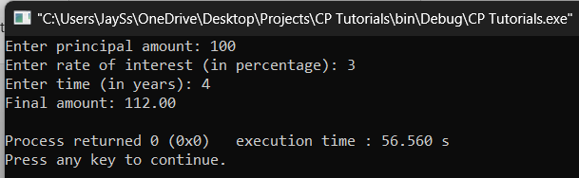

1. A boy was punished and asked to cover 5 rounds of the circular ground. Area of the ground is 32000 sqmtr. Calculate how many kilometres the boy has covered.

**Code:**

#include <stdio.h>

#include <math.h>

int main()

{

int area, rounds;

float radius, distance;

printf("Enter area of the ground (in sqmtr): ");

scanf("%d", &area);

printf("Enter number of rounds: ");

scanf("%d", &rounds);

radius = sqrt(area / M_PI);

distance = 2 * M_PI * radius * rounds;

printf("Distance covered: %.2f kilometres\n", distance / 1000);

return 0;

}

**Output:**

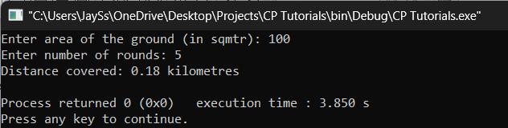

1. Read the price of item in decimal form. For example, 12.52 and separate rupee and paise from the given value. For example, 12 rupees and 52 paise.

**Code:**

#include <stdio.h>

int main()

{

float price;

int paise, rupees;

printf("Enter price: ");

scanf("%f", &price);

paise = (int)(price * 100);

rupees = paise / 100;

paise = paise % 100;

printf("Rupees: %d\n", rupees);

printf("Paise: %d\n", paise);

return 0;

}

**Output:**

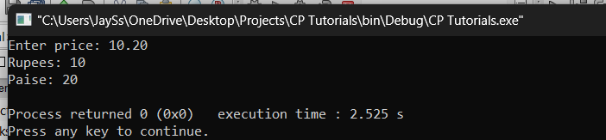

1. To swap the value of two numbers
2. Using a  temporary variable

**Code:**

#include <stdio.h>

int main(void) {

int x, y, temp;

printf("Enter value of x: ");

scanf("%d", &x);

printf("Enter value of y: ");

scanf("%d", &y);

temp = x;

x = y;

y = temp;

printf("x: %d\n", x);

printf("y: %d\n", y);

return 0;

}

**Output:**

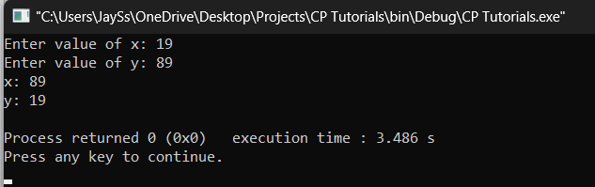

1. Without using temporary number.

**Code:**

#include <stdio.h>

int main(void) {

int x, y;

printf("Enter value of x: ");

scanf("%d", &x);

printf("Enter value of y: ");

scanf("%d", &y);

x = x + y;

y = x - y;

x = x - y;

printf("x: %d\n", x);

printf("y: %d\n", y);

return 0;

}

**Output:**

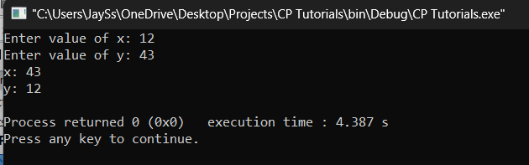

1. To find greatest of two and three numbers using the ternary operator.

**Code:**

#include <stdio.h>

int main(void) {

int x, y, max;

printf("Enter value of x: ");

scanf("%d", &x);

printf("Enter value of y: ");

scanf("%d", &y);

max = (x > y) ? x : y;

printf("Maximum of x and y: %d\n", max);

return 0;

}

**Output:**

